**Writing code in Eclipse to finish the following Programming Exercises in textbook.**

**To receive full-mark of the lab, please show me your code and running results before leaving.**

**Task:**

(*Parallel matrix multiplication*)

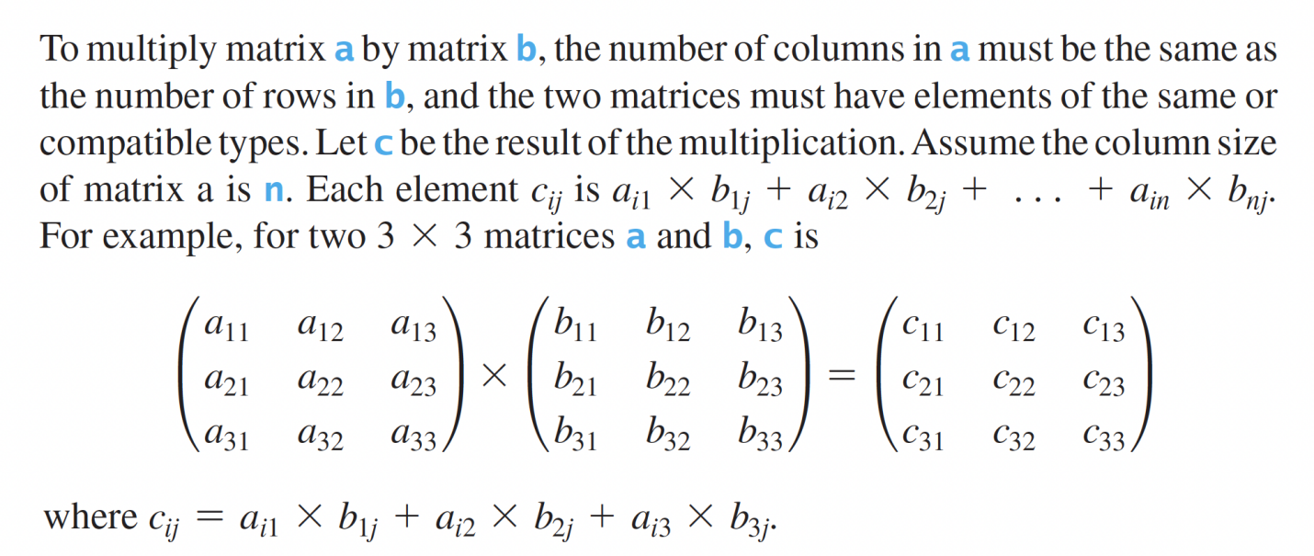

Suppose you have multiple processors, so you can speed up the matrix multiplication. Implement the following method in parallel.

**public static double**[][] parallelMultiplyMatrix(**double**[][] a, **double**[][] b)

Write a test program that measures the execution time for multiplying two 2,000 * 2,000 matrices using the parallel method and sequential method, respectively.